Lab #1 Step-by-step
Save all analyses in the same output, print it out at the end; delete un-needed tables and annotate (explain) important entries in the remaining tables.

- Download the “All data sets” file from http://www.csun.edu/~ata20315/psy524 and extract all of the files to either your USB drive or your campus Udrive.
Step 1 – Downloading and saving the data: This step requires that you use the right mouse button to click on the Lab 1 #1 link on the class website and select “Save target as…”
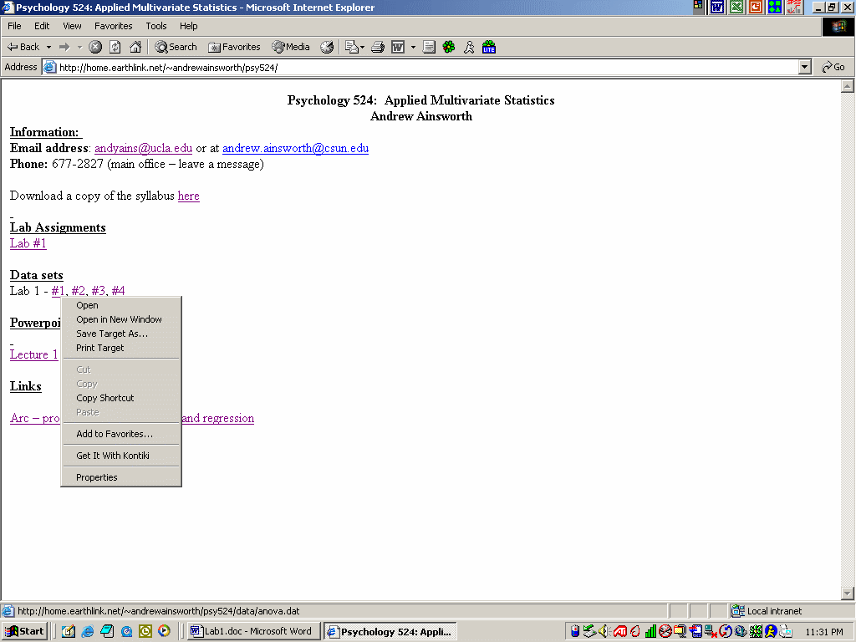
save it to either a USB drive that you have with you or your CSUN Udrive so that you can access it later from any computer on campus (or at home). If those fail save it to a temp file on the C: drive on the computer your working on (this may mean you’ll have to add the temp file first if it isn’t there).

- Open “anova.dat” (tab delimited text file) and convert it to a .sav file
Step 2 – Importing file into SPSS: Once it is saved open up SPSS and find the saved file (keep in mind that the file extension is .dat so change the file extension appropriately). As you open it SPSS will ask a series of questions in order to transfer the .dat file into a .sav file.
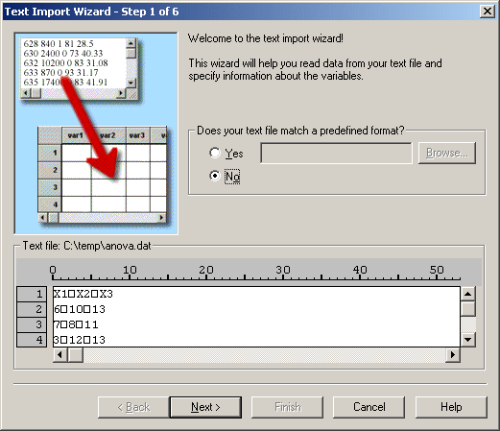
Click on “Next”; select “Delimited” and “Yes” – “Next”; leave the defaults - “Next”; “Tab” only - “Next”; “Next”, and “Finish”.

Your data should look like this:
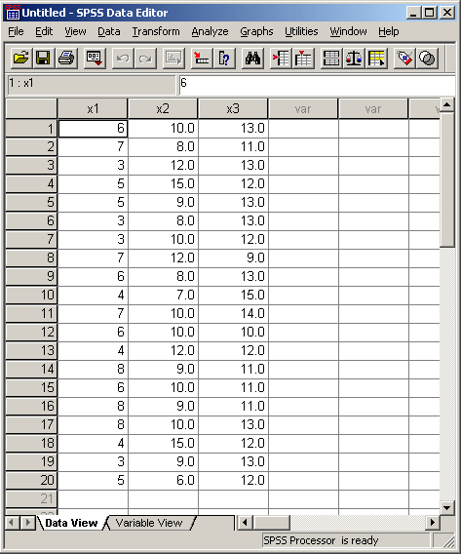
  - Perform a one-way between subjects ANOVA using the data (hint you may need to do some rearranging), make sure and include descriptives, homogeneity of variance test, Brown-Forsythe test, a planned comparison of (group 1 vs. groups 2 and 3) and group 2 vs. group 3, and both a Scheffe and a Tukey test.
Step 1 – Rearranging data for between subjects: the data needs to be in a format that has each subject only having a single response on one DV with a separate variable that indicates group membership.
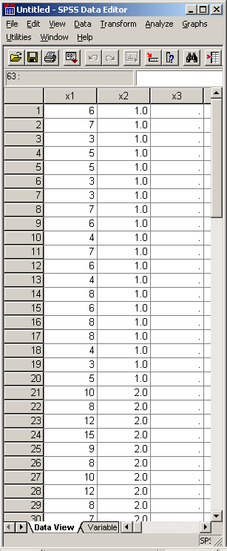
The way I did this was to use Transform -> Compute and put x2 into “Target Variable” and a 1 into “Numerical Expression”, then click on “If”. Type the expression $casenum <= 20 and then hit “continue” and then “Paste”. Copy the syntax and paste it two times so you have three of the same commands twice. Then change a couple of things so it looks like this:
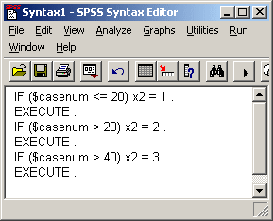
(What you are really doing is a little inefficient because you are first placing 2s over every entry greater then 20 and then overwriting it with 3s in the third command, but it works) Select Run -> All and voila.
Step 2 – Analysis: Select Analyze -> Compare Means -> One-Way Anova
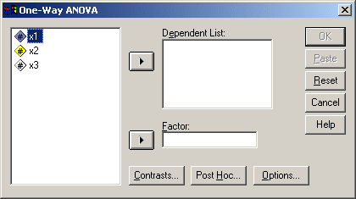
Select x1 and move it to “dependent list” and x2 to “Factor”

For contrasts - Click on “Contrasts…” and for contrast 1 of 1 insert a 2 into the “coefficient box” and then “add”, repeat with a -1 and another -1 (this assigns weights to the groups in order first group gets 2, second -1 and so on). Click on “Next” so it says contrast 2 of 2 and repeat the previous steps with 0, 1, and -1.

For Post Hoc adjustments - Click on “Post Hoc...” select Scheffe and Tukey -> continue.

All else - Click on “Options…” select Descriptive, Homogeneity of Variance Test, and Brown-Forsythe -> Continue and then click on OK.

  - Perform the same analysis using simultaneous linear regression with the same planned comparisons from step A above. Include estimates, model fit, descriptives, and part and partial correlations.
Step 1 – Create planned comparisons as predictors by using the same numerical weights in the problem above. To do this you can use the same syntax from earlier, copy and paste so there are five commands and just modify it a little so that is looks like this:
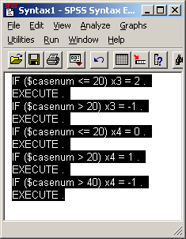
You should now have 4 columns two of which you just made and are made up of the weights.

Step 2 – Regression: In the main SPSS window select Analyze -> Regression -> Linear and you’ll get a window like this:
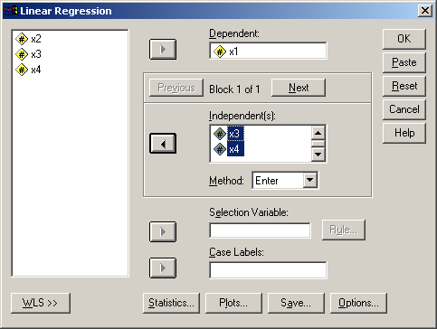
Move x1 to “Dependent” and x3 and x4 to “Independent(s)”. Click on “Statistics…” and select Estimates, Model Fit, Descriptives and Part and Partial Correlation -> Continue and then hit OK.

  - Perform a one-way within subjects ANOVA using the same data. Display means for the variable, descriptive, effect size and do a Bon Feroni contrast.
Step 1 – Reorganize the data: In order to perform a one-way within subjects ANOVA the data needs to show that each subject has multiple responses. In other words the data needs to be in the format it was when you originally downloaded it. Copy each group’s data from X1 into a separate new column, making three columns. Click on variable view on the bottom of the page and change the names of three new columns to be x5, x6, x7 so it looks like this:
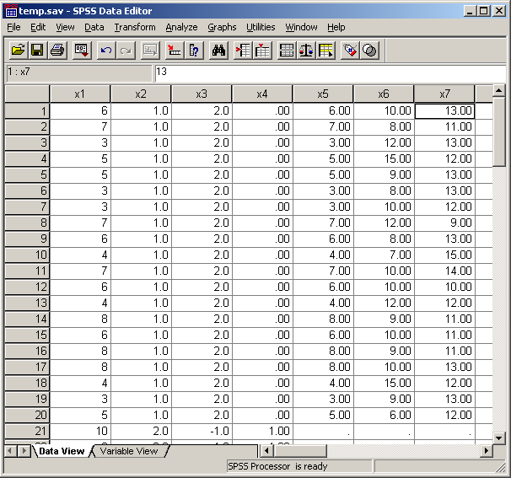

Step 2 – Analysis: Click on Analyze -> General Linear Model -> Repeated Measures. In “Within subject factor name” put in something like “trial” of “x” and in “number of levels” put in 3 and click on “add”, and then define:
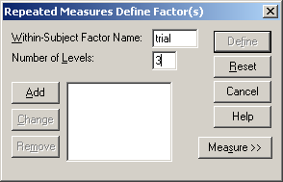
Using the mouse select x5, x6, and x7 and move it over to “Within subjects Variables”
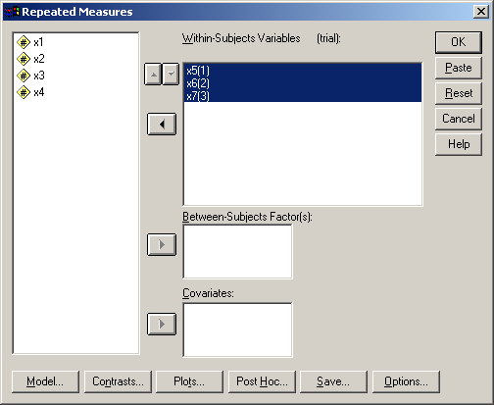

Click on “Options” and move “overall” and “trial” over to “display means for”, click on “compare means for” and change confidence interval adjustment to “Bonferoni”. Click on “Descriptive Statistics” and “Estimates of Effect Size”:
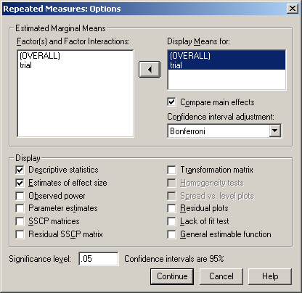
“Continue” -> “OK”.

- Open “anova2.txt” (tab delimited) and convert it to a .sav file (use the same steps as in #2 above to convert). Perform a factorial between subjects ANOVA. Include polynomial contrast on A, plot A vs. B, Scheffe and Tukey on A, display means for everything, descriptives, effect size and homogeneity test.

Step 1 – Download data: Follow the same steps as in the first problem above but just keep in mind the file extension this time is .txt:
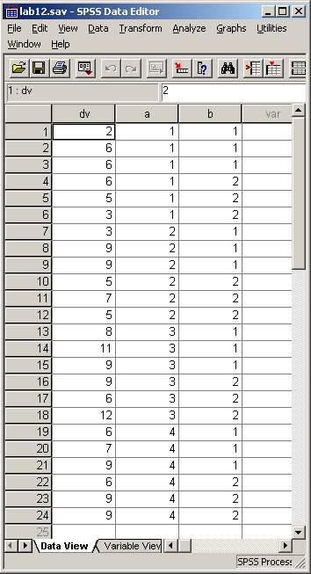

Step 2 – Analysis: Analyze -> General Linear Model -> Univariate.
Move DV into “Dependent Variable” box and a and b in to the “Fixed Factor” box. Select “contrast” and highlight “a(none)” and in the “change contrast” box change the drop down menu to “polynomial” and click on “change” and then hit OK:
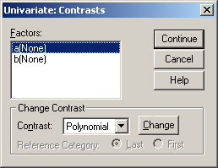
Select “Plots” and move “a” into horizontal axis and “b” into separate lines, hit “add” and then “continue”.

Select “Post Hoc” and move “a” into “Post Hoc test for”; select “Scheffe” and “Tukey” and then hit “continue”.

Select “Options” and move everything into “Display means for”, select “Descriptive Statistics”, “Estimates of Effect Size” and “Homogeneity Test”. Hit “Continue” and then “OK”.

- Open “anova3.txt” and and convert it to a .sav file. Give me a factorial within subjects ANOVA. It is a design that has each person reading two different types of novels over three month periods, the DV is arbitrary (e.g. rating or something). Remove the polynomial contrast on novel, plot novel vs. month, display means for everything, descriptives and effect size.
Step 1 – Download data: Same steps as earlier.

Step 2 – Analysis: Analyze -> General Linear Model -> Repeated Measures. Make two factor, the first is novel with 2 levels and month with 3 levels:
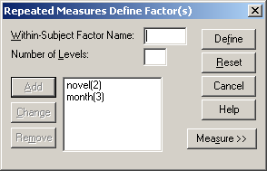
Hit “Define” and if you did the right way you should be able to move all of them over together:
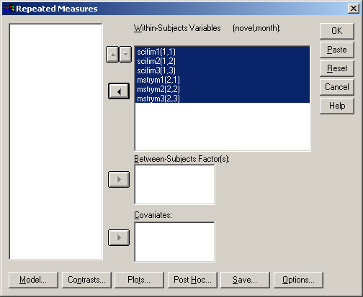

Select “contrast” and hightlight novel changing the bottom menu to “none” and hitting “change”.

Select “Plots” and move novel to horizontal axis and month to separate lines, “add” and then “continue”.

Select “Options” and move everything into “display means for”, select “Descriptives” and “Effect Size” -> Continue -> OK.

- Open “anova4.txt” and and convert it to a .sav file. Give me a mixed ANOVA (1 between and 2 within; gender differences in sex drive before and after intervention, four trials each), include a plot of gender by trial for each intervention level, descriptives, effect size and homogeneity test.

Step 1 – Download data: Same process as earlier.

Step 2 – Analysis: Analyze -> General Linear Model -> Repeated Measures
Create “interven” with 2 levels and “add”, then create “trial” with 4 levels and “add” -> define.

Highlight everything except gender and move it over to “Within Subjects Variables” and move gender into “Between Subjects Factors”.

Click on “Plots” and move gender to horizontal axis, trial to separate lines and intervention to separate plots; click “add” and then “continue”. Click “options” and select “descriptives”, “effect size” and “homogeneity tests”. Click on continue and then OK.

And that’s it.

